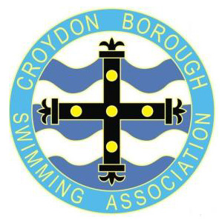
CROYDON BOROUGH SWIMMING ASSOCIATION
ANNUAL CHAMPIONSHIPS & AGE GROUP COMPETITIONS 2026
Closed Championship Gala (Level 4 – TBA)

To be held at Whitgift School, off Nottingham Road, Haling Park, South Croydon, Surrey. CR2 6YT
Saturday 14th March & Sunday 15th March 2026

Event timings vary dependent upon gala date.
Please use short-course entry times.
If you do not have a time and wish to enter an event, please tick the box and write NT in the adjacent time box.
Qualifying times exist for all 400m & 200m individual events. “No Time” entries for these events will be rejected.
Ages as at: 15th March 2026
Closing date for entries: 6th March 2026

Entry Form for Affiliated Club Members

Name: ................................................................................................... Open/Male or Female

Date of Birth: .................................. Age as at 15th March 2026 ................ yrs

Swim England ID number: .................... Para-Swimming Classification: S….. SB….. SM…..

Club: ........................................................................................

Email address (capitals please)...........................................................................................

Postal address: .........................................................................................

.................................................................................. Post Code: ....................

Telephone No:(home).....................................................................

(mob) ......................................................................

Entry Fees: ............... @ £4.50 each = £.......................

TOTAL AMOUNT PAYABLE: £........................

Payment sent: To Club………….. By BACS to CBSA…………..

Please send payment to your club if your club is managing entries. For individual entries please send a bank payment to:
Sort Code 60-50-01, Account No.10307265, A/C name: Croydon Borough Swimming Association
using your surname and CBSA as the payment reference.

All entry forms (both sheets) and any enquiries to:

Nick Hallam
34 Kingswood Avenue, SOUTH CROYDON, Surrey. CR2 9DQ
Tel: 07753 269989 email: admin@croydonboroughsa.org

CROYDON BOROUGH SWIMMING ASSOCIATION
ANNUAL CHAMPIONSHIPS & AGE GROUP COMPETITIONS 2026
Closed Championship Gala (Level 4 – TBA)

To be held at Whitgift School, off Nottingham Road, Haling Park, South Croydon, Surrey. CR2 6YT
Saturday 14th March & Sunday 15th March 2026

ENTRY FORM

NAME …………………………………………………………….

