**CROYDON BOROUGH SWIMMING ASSOCIATION**

**ANNUAL CHAMPIONSHIPS & AGE GROUP COMPETITIONS 2025**

**Closed Championship Gala (Level 4 – TBA)**

To be held at Whitgift School, off Nottingham Road, Haling Park, South Croydon, Surrey. CR2 6YT

Saturday 15th March & Sunday 16th March 2025

Event timings vary dependent upon gala date.

Please use short-course entry times.

If you do not have a time and wish to enter an event, please tick the box and write NT in the adjacent time box.

Qualifying times exist for all 400m & 200m individual events. “No Time” entries for these events will be rejected.

**Ages as at: 16th March 2025**

**Closing date for entries: 7th March 2025**

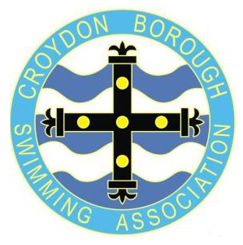

**Entry Form for Non-Affiliated Club Members**

Name: ................................................................................................... Open/Male or Female

Date of Birth: .................................. Age as at 16th March 2025 ................ yrs

Swim England ID number: .................... Para-Swimming Classification: S….. SB….. SM…..

Club: ........................................................................................

Email address (capitals please)...........................................................................................

Postal address: .........................................................................................

.................................................................................. Post Code: ....................

Telephone No:(home).....................................................................

(mob) ......................................................................

Entry Fees: ............... @ £6.00 each = £.......................

TOTAL AMOUNT PAYABLE: £........................

Payment sent: To Club………….. By BACS to CBSA…………..

Please send payment to your club if your club is managing entries. For individual entries please send a bank payment to:

Sort Code 60-50-01, Account No.10307265, A/C name: Croydon Borough Swimming Association

using your surname and CBSA as the payment reference.

All entry forms (both sheets) and any enquiries to:

Nick Hallam

34 Kingswood Avenue, SOUTH CROYDON, Surrey. CR2 9DQ

Tel: 07753 269989 email: admin@croydonboroughsa.org



**CROYDON BOROUGH SWIMMING ASSOCIATION**

**ANNUAL CHAMPIONSHIPS & AGE GROUP COMPETITIONS 2025**

**Closed Championship Gala (Level 4 – TBA)**

To be held at Whitgift School, off Nottingham Road, Haling Park, South Croydon, Surrey. CR2 6YT

Saturday 15th March & Sunday 16th March 2025

**ENTRY FORM**

**NAME** **…………………………………………………………….**

